(In This document Percona xtraBackup is old version so please download according to database version.)

#### Installation of Percona xtraBackup on mysql database
Go to the site

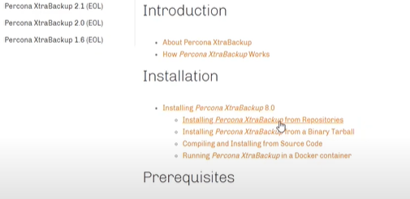

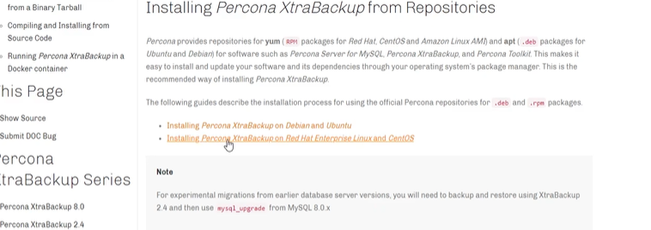

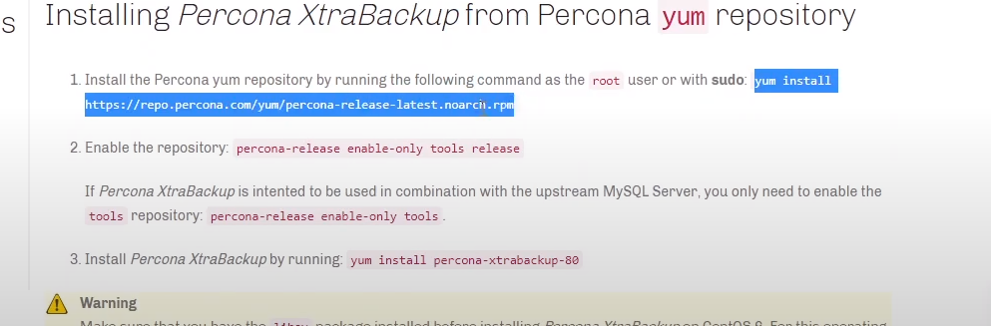

List of packages
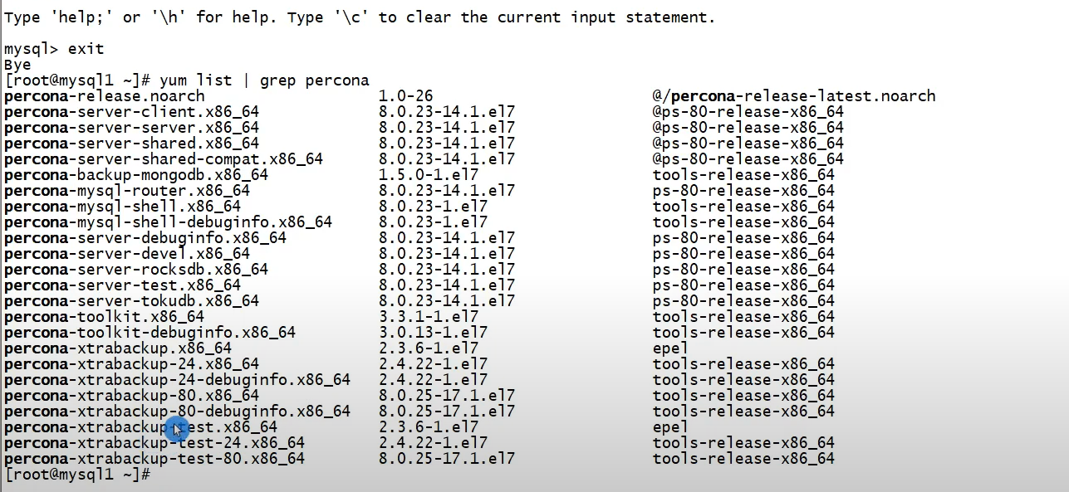

Enabling the packages. 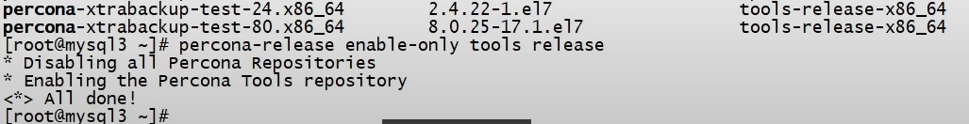

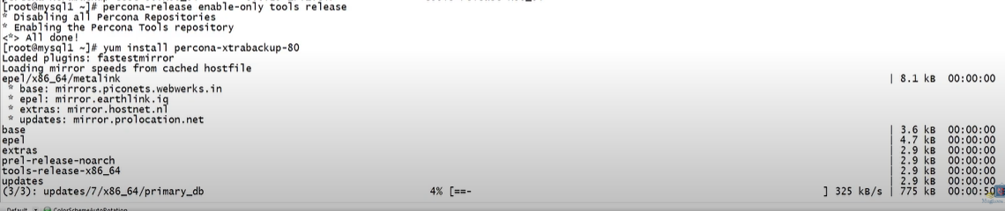
Installation of Percona xtraBackup on ubantu os

Installing Percona XtraBackup via percona-release¶
Percona XtraBackup, like many other Percona products, is installed with the percona-release package configuration tool.
- Download a deb package for percona-release the repository packages from Percona web:
$ wget https://repo.percona.com/apt/percona-release_latest.$(lsb_release -sc)_all.deb

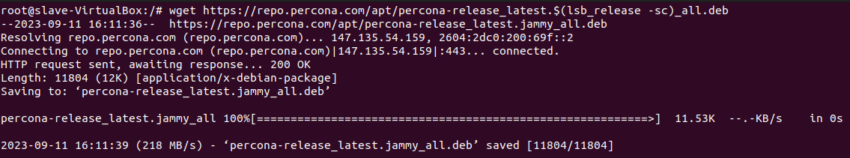
- Install the downloaded package with dpkg. To do that, run the following commands as root or with sudo:
$ sudo dpkg -i percona-release_latest.$(lsb_release -sc)_all.deb

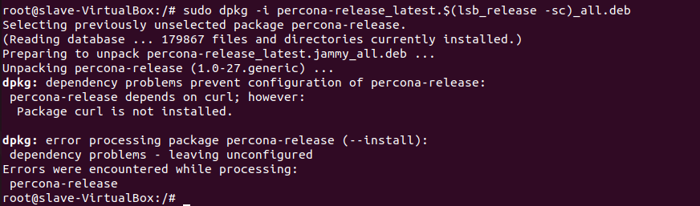

Once you install this package the Percona repositories should be added. You can check the repository setup in the /etc/apt/sources.list.d/percona-release.list file.
- Enable the repository: percona-release enable-only tools release
If Percona XtraBackup is intended to be used in combination with the upstream MySQL Server, you enable only the tools repository: percona-release enable-only tools.
- After that you can install the percona-xtrabackup-24 package:
$ sudo apt install percona-xtrabackup-24 (for version 2.0.x)
sudo apt-get install percona-xtrabackup-80 (For version 8.0.x on mysql version 8.0)

xtrabackup –-version (To check version)

- In order to make compressed backups, install the qpress package:
$ sudo apt install qpress

Connecting to the server¶
The database user used to connect to the server and its password are specified by the xtrabackup --user and xtrabackup –password option:

$ xtrabackup --user=DVADER --password=14MY0URF4TH3R --backup \
--target-dir=/data/bkps/
$ innobackupex --user=DBUSER --password=SECRET /path/to/backup/dir/
$ innobackupex --user=LUKE --password=US3TH3F0RC3 --stream=tar ./ | bzip2 -
If you don’t use the xtrabackup --user option, Percona XtraBackup will assume the database user whose name is the system user executing it.

Other Connection Options¶
According to your system, you may need to specify one or more of the following options to connect to the server:

Option Description
–port The port to use when connecting to the database server with TCP/IP.
–socket The socket to use when connecting to the local database.
–host The host to use when connecting to the database server with TCP/IP.

### Taking Full backup with using Percona Xtrabackup
Percona XtraBackup is an open-source hot backup utility for MySQL - based servers that does not lock your database during the backup. It can back up data from InnoDB, XtraDB, and MyISAM

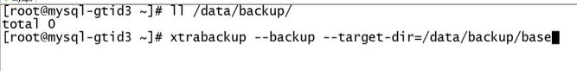
First make directory where you wants to take backup
And then take full backup
# xtrabackup --backup --target-dir=/data/backup/base
--target-dir=/data/backup/base => where the backup will be stored.
Directory where backup done.
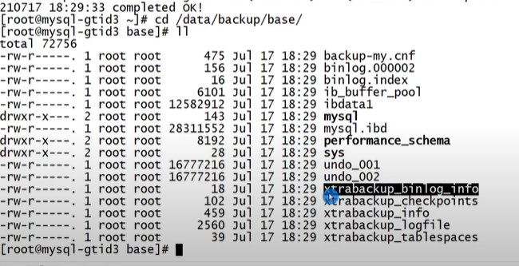

Xtrabackup_binlog_info = binlog position
Xtrabackup_loginfo= redo log file
Backup-my.cnf = configuration file backup

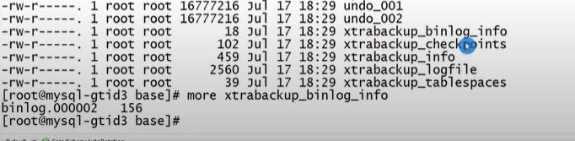

Xtrabackup_checkpoints = start and last LSN no show. It is used for incremental backup or point of recovery.
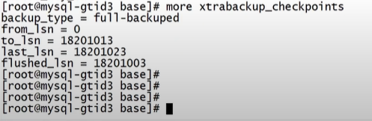

Preparing a backup
After you made a backup with the xtrabackup --backup option, you’ll first need to prepare it in order to restore it.
The xtrabackup --prepare step makes the files perfectly consistent at a single instant in time, so you can run InnoDB on them.

$ xtrabackup --prepare --apply-log-only --target-dir=/data/backups/base

Restoring a Backup

For restoration first stop mysqld

$ Systemctl stop mysqld

Restoration command
$ xtrabackup –copy-back --target-dir=/data/backup/base

If you don’t want to save your backup, you can use the xtrabackup --move-back option which will move the backed up data to the datadir.
If you don’t want to use any of the above options, you can additionally use rsync or cp to restore the files.
$ rsync -avrP /data/backup/ /var/lib/mysql/

You should check that the restored files have the correct ownership and permissions.
$ chown -R mysql:mysql /var/lib/mysql

When relay-log-info-repository=TABLE is enabled, the instance recovered from the backup has errors in the error log, like the following:
2019-08-09 12:40:02 69297 [ERROR] Failed to open the relay log '/data/mysql-relay-bin.004349' (relay_log_pos 5534092)
To avoid these types of issues, enable relay_log_recovery or execute RESET SLAVE prior to CHANGE MASTER TO.

Incremetal backup
$ xtrabackup --backup --target-dir=/data/backup/inc1
--incremental-basedir=/data/backup/base

Here we see two backup folder one is full and another one is incremental
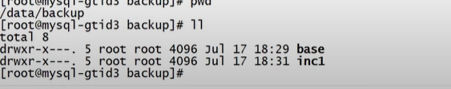

And if we take second incremental backup then
$ xtrabackup --backup –target-dir=/data/backup/inc2 --incremental-basedir=/data/backup/inc1

Preparing a backup
We Preparing three backup = full backup, incremental 1 and incremental 2 prepare all of them
For Full Backup
$ xtrabackup --prepare --apply-log-only --target-dir=/data/backups/base

For incremental 1
$ xtrabackup --prepare --apply-log-only --target-dir=/data/backups/base --incremental-dir=/data/backups/inc1

For incremental 2
$ xtrabackup --prepare --target-dir=/data/backups/base --incremental-dir=/data/backups/inc2

Restoring a Backup
It is as similar as above.

Compressed Backup
$ xtrabackup --backup --compress --target-dir=/data/compressed/

The xtrabackup --compress uses the qpress tool that you can install via the percona-release package configuration tool as follows:
$ sudo percona-release enable tools
$ sudo apt update
$ sudo apt install qpress

If you want to speed up the compression you can use the parallel compression, which can be enabled with xtrabackup –compress-threads option. Following example will use four threads for compression:
$ xtrabackup --backup --compress --compress-threads=4 --target-dir=/data/compressed/

Preparing the backup¶
Before you can prepare the backup you must uncompress all the files. Percona XtraBackup has implemented xtrabackup --decompress option that can be used to decompress the backup.
$ xtrabackup --decompress --target-dir=/data/compressed/

When the files are uncompressed you can prepare the backup with the xtrabackup --prepare option:
$ xtrabackup --prepare --target-dir=/data/compressed/

Restoring the backup¶

$ xtrabackup --copy-back --target-dir=/data/backups/

Encrypted Backup
in order to add another layer of protection to the backups. Encryption is done with the libgcrypt library.
--encrypt=ALGORITHM - currently supported algorithms are: AES128, AES192 and AES256

For encryption backup firstly Encryption key can be generated with command like:
$ openssl rand -base64 24
Example output of that command should look like this:
GCHFLrDFVx6UAsRb88uLVbAVWbK+Yzfs
This value then can be used as the encryption key

Using the --encrypt-key option¶

$ xtrabackup --backup --target-dir=/data/backups --encrypt=AES256 --encrypt-key="GCHFLrDFVx6UAsRb88uLVbAVWbK+Yzfs"

Using the --encrypt-key-file option
$ xtrabackup --backup --target-dir=/data/backups/ --encrypt=AES256 --encrypt-key-file=/data/backups/keyfile

Decrypting Encrypted Backups
Percona XtraBackup xtrabackup --decrypt option has been implemented that can be used to decrypt the backups:
$ xtrabackup --decrypt=AES256 --encrypt-key="GCHFLrDFVx6UAsRb88uLVbAVWbK+Yzfs"
--target-dir=/data/backups/

Percona XtraBackup doesn’t automatically remove the encrypted files. In order to clean up the backup directory users should remove the *.xbcrypt files. In Percona XtraBackup 2.4.6 xtrabackup --remove-original option has been implemented that you can use to remove the encrypted files once they’ve been decrypted. To remove the files once they’re decrypted you should run:
$ xtrabackup --decrypt=AES256 --encrypt-key="GCHFLrDFVx6UAsRb88uLVbAVWbK+Yzfs" --target-dir=/data/backups/ --remove-original

Preparing Encrypted Backups
$ xtrabackup --prepare --target-dir=/data/backups/

Restoring Encrypted Backups
$ xtrabackup --copy-back --target-dir=/data/backups/

